Configuring Autopilot
- Load up the intune management console
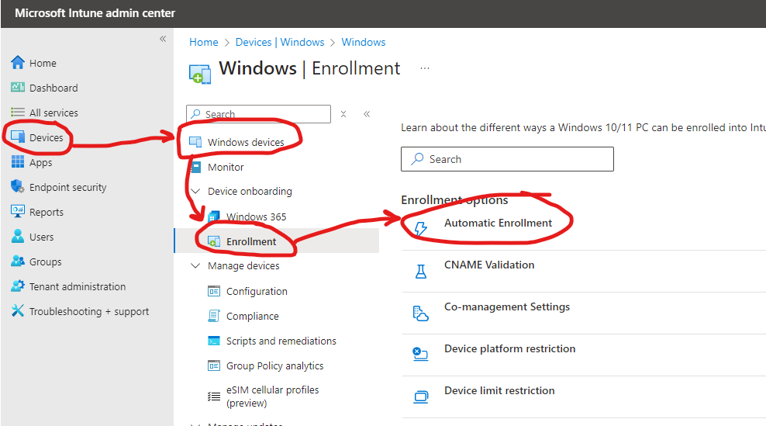
- Load up the Automatic enrolment page and set the default URLSs using the highlighted link and save

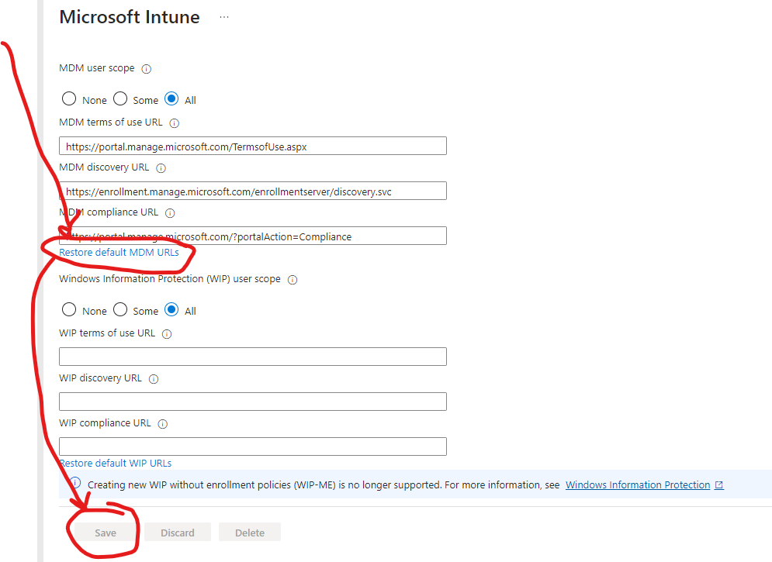
- In the DNS for the domain you need to put the following cname:
Type | Host name | Points to | TTL
CNAME | EnterpriseEnrollment.youdomain.com | EnterpriseEnrollment-s.manage.microsoft.com | One hour
You can use the checker on the CNAME validation to make sure its working
- Go back to the Enrollment page and click CNAME Validation
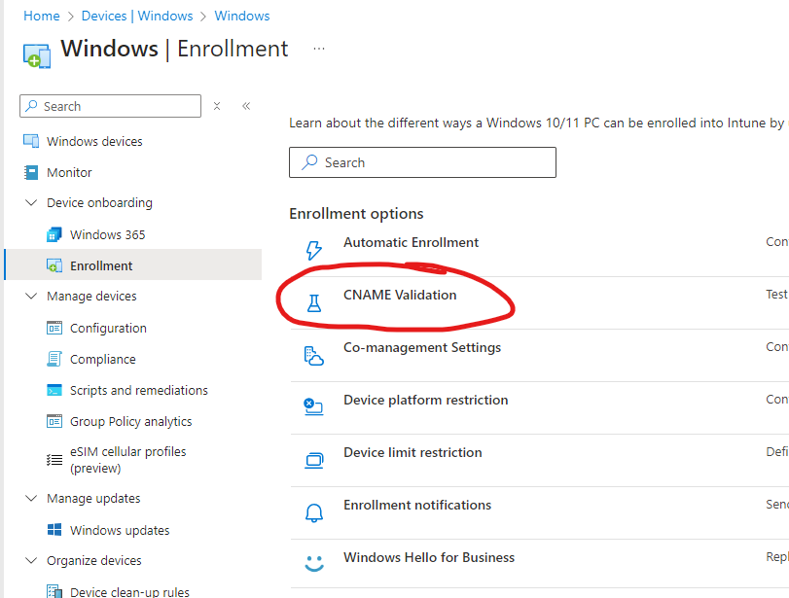
- Scroll down on the enrolment page and load the Deployment profiles
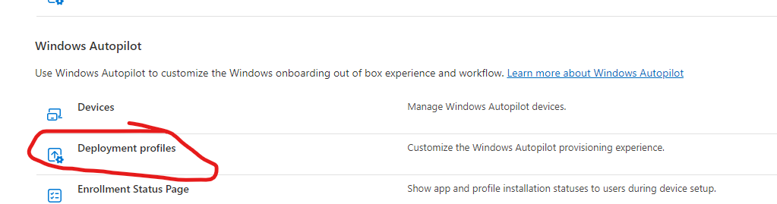

- Create a deployment profile with the following settings that define the OOBE experience
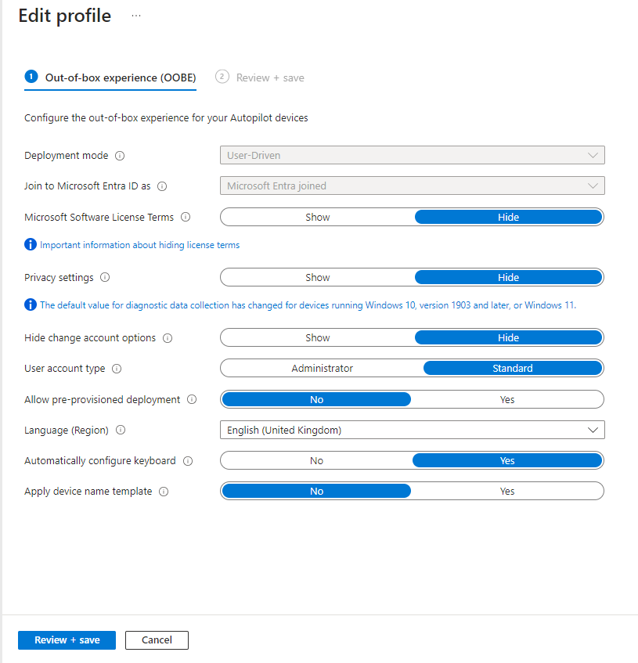
Assign it to all devices
- That should be a completed Autopilot setup

Please note this is separate to the configuration policies and settings for configuring the machine once it has joined the AAD

Notes:
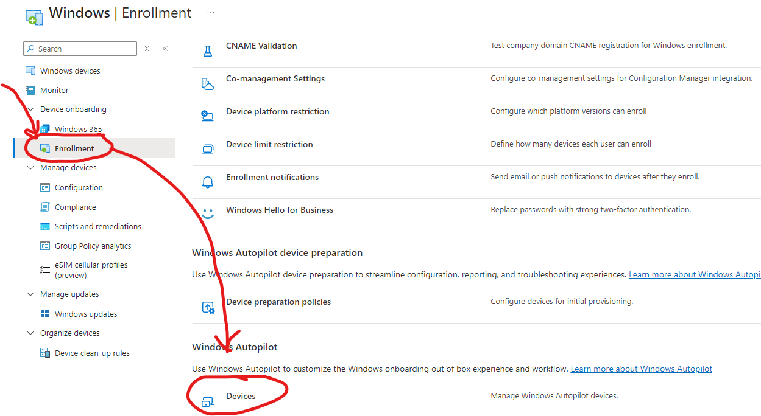
This section shows devices that have successfully enrolled through autopilot
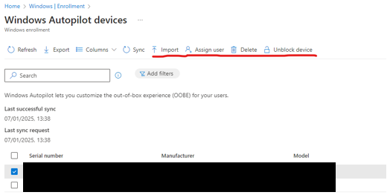
If a machine is sold or disposed of it will need to be removed from here to stop it enrolling back to this tenant. You can also assign users here for further customisation or pre-import machines device hashes so they will skip several OOBE steps (probably not needed unless at large scale)

The following sections are optional but for controlling deployments more
